Game Meat / Viande de gibier
Wild Boar / Sanglier
Salami - Sliced

Ingredients: Domestic Wild boar, Pork, Beef, Spices, Sea salt, Cane sugar, Cultured celery powder, Rice flour, Starter culture, Natural wood smoke.
Ingredients: Sanglier domestique, Porc, Bœuf, Epices, Sel de mer, Sucre de canne, Poudre de céleri de culture, Farine de riz, Culture starter, Fumée de bois naturel.

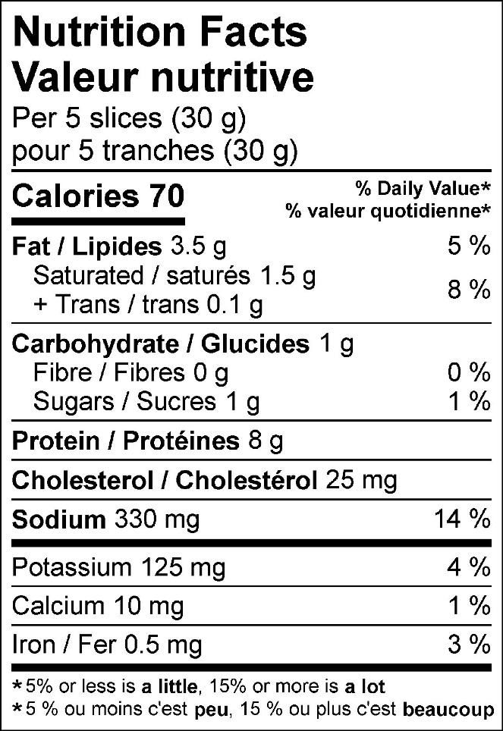

125 g pack
